Games Design Document

**Insomnia: Nightmare Chapter**

**Jerome Gardiner**

Contents

**User Experience** 4

Overview 4

Deployment 4

Background 5

Key Features 5

Depth 6

Reward System 6

World 6

**Gameplay** 7

Objectives 7

Mechanics 7

Rules 8

Controls 9

Interactive Elements 9

Physics 9

Characters 10

Weapons 11

Items 11

Abilities 13

AI and Behaviour 13

Balance 14

Tutorial 14

**Narrative** 15

Style and Structure 15

Background Story 15

Storyline 15

**Visuals** 16

Style 16

World 16

**Music and Sounds** 17

Style 17

Ambience 17

**Technical Aspects** 18

Technologies 18

Tools 18

**Appendix** 19

**References** 23

# **User Experience**

## Overview

Insomnia is a survival horror game with a focus on exploration and puzzle-solving to escape a dangerous creature.

The game is based in a 3d world from a first-person perspective and avatar based, where there is depth in replaying as different characters with different skills to explore new areas.

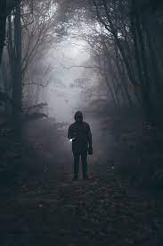The most important and exciting aspect of the game is the day and night cycle and the multiple main characters you play. You play a cast of characters who are trapped in the same area, each with their own motivations and objectives, and can either work together or hinder each other in escape. All are necessary to progress, but not all will make it out alive.

Manage your resources of supplies, batteries and sleep to make the most of the day and the night, and understand the skills and abilities of every character to explore and fight each creature variant, or each other. You must solve puzzles to create safe areas, risk sleeping away the safe day or risk sleeping in the dangerous night, especially dealing with the creatures and puzzles that change from past play throughs or even characters working on their own. Live, die and return as a new person to better understand the world, make changes to the level to make the next run easier and travel further.

A core element of the game is a survival-based exploration as you iterate over the same level, run and hide from one dangerous enemy with many forms and collect all the items you need to survive the night and see how long you can remain with one character. Secondary elements are collecting documents to better understand the creature and the world as well as rewards to make the next run-through easier to make it to the end of the game.

## Deployment

The platform will be on the PC platform, likely through Steam.

The target audience will include female and male users between 16-31. The game will be designed for people with hardcore preferences, as it would be designed for established PC gamers and would require at least some investment to explore and complete portions of the game.

A significant portion of the content will reward exploration and investment over casual play. An example of such a player will be a 21-year-old who enjoy story horror titles like Slender-man and Outlast.

## Background

This game is heavily influenced by Alan Wake and Slenderman: Arrival with the use of the flashlight for combat as well as a small open world where you run from a singular, terrifying enemy.

The art and tone of the game is largely taken from Alan Wake and other titles like Salt. The day will include simple but charming graphics with bright colours and calming sounds to encourage exploration and peace, but will take on a darker, blue palette similar to Alan Wake when night falls, to show the danger and fear of the night.

## Key Features

* **Survive the night**, hide and run increasingly difficult night cycles, using your wits, knowledge of the map and tools to make it just that little bit longer until the day comes. At the end of each night, the world changes through the actions of the characters, whether you’re playing them or not.
* **Manage the survivors,** who each have their own skills, motivations and objectives other than escaping. Learn their motivations, choose who gets the items and whether they share, and ultimately decide who will escape or who will be left behind.
* **Mysteries abound** as you delve further into the map. Unlock new locations and collect crucial documents to piece together the mysteries of this world and how to escape it. Some doors can only be opened with the right character.
* **Sleep is a resource**. Manage when and where to sleep to make use of the safety in the day and avoiding the night. Don’t get caught without asleep, and don’t sleep too long while other characters are planning their escape without you.
* **Find tools and puzzles** and see how far you can get as you power up generators to make safe areas, get better torches to ward off the darkness and unlock new areas filled with mystery, danger and puzzles.
* **Face the Stranger**, a creature as mysterious as it’s deadly. You must out run and outwit it on every point to survive. Be careful of its ever-changing behaviours.
* **Nightmare mode.** There can be no escape from the night. Using all your wits and tools, see how long you can last without the light of the sun, if you can even escape.

## Depth

Insomnia is designed to be easy to learn but gains complexity and depth the more you learn of items and areas. The narrative is character driven, and while you can survive as long as you can, you’ll need to master all characters to truly escape. As you progress, you get a steadily growing inventory of tools and resources that even could be shared between characters.

The key to victory is to outsmart the Stranger and complete all the puzzles to escape. The Stranger must be avoided, with the greatest learning curve is the unique ways to use the tools and knowledge of the map to escape the creature at every turn, but it too can learn with new behaviours.

## Reward System

* Most of the rewards in the game will derive from exploration. In Insomnia, the world is packed with new areas to explore with the largest reward being safe places to sleep, resource boxes that can be used to share items between characters and eventually an ending, good or bad.
* You shall be rewarded for completing challenges, stealth, puzzles and opening a locked door, with new resources and items which can be used for later progression.
* Progressing shall also provide a sense of reward as you can unlock areas that remain unlocked for other characters, providing a sense of accomplishment and even creating shortcuts to world exploration to traverse old areas. The user will see how they have mastered each area, their puzzles, and items to use as they race pass them to explore more.

## 

## World

While this game is simplistic in nature, it will use particles and colour palettes to create a dark and foreboding style.

The world is based in a forest, segmented by natural and manmade barriers. Though there is room to grow, the Nightmare Chapter has one level, with 5 unique areas the player can discover, each with their own main challenges.

|  |  |  |
| --- | --- | --- |
| *Name* | **Description** | **Attributes** |
| Ranger’s Complex | Tutorial Area. Points of interest are the main complex, locked resource room, a keypad solar power station (undamaged until later levels), altar section and cave.  Leads to forest by powering the safe zone. | Unlock Nikki  Blue key (Cabin)  Blue door (resource room)  Green door (extra room)  Ranger’s note #1(for keypad in Cabin)  Key pad (power station)  Generator (power station)  Security Note #1 (Altar)  Climber Note #1 (Cave)  Ranger’s note (extra room)  High beam (extra room) |
| Forest | Simple forest with paths, 2 tent areas, 2 generators, cabin zone, fire trails. Science zone with card swipe.  A rock climbing place to industrial zone. A password protected lock to Campsite zone. | Unlock Ranger  Green Key  Green Door (cabin)  Fuse (generator repair)  Gas can (generator repair)  Broken generator  Generator (science zone)  Card #1 (1 tents)  Card swipe (science zone)  Computer (science zone)  Science Note #1 (password, 2 tents)  Ranger’s note #2 (Cabin)  Security note #2 (generator) |
| Campsite | A segmented complex outside of the forest reserve. Defined paths, 2 cabin zones, a watchtower, 3 campsites. Altar zone. Science Zone.  Rock climbing shortcut to forest and ranger’s complex. Rock climbing shortcut to watchtower. | Unlock Climber  Solar cell generator (broken)  Ranger’s note #3 (for fuse, watchtower)  Fuse (Altar zone)  Green door (watchtower)  Red door (2 cabin)  Blue door (1 cabin)  Security Note #3 (for keypad, 1 cabin)  Science Note #2 (Science zone)  Climber Note #2 (Altar zone)  Climber Note #3 (2 tents) |
| Industrial | Walled off on every side, this complex is built on a mountain side with barracks, mining equipment and factories with many floors. The complex includes 3 electric doors, 3 generators, 2 main buildings, 1 watch tower, 2 science areas, 1 cave.  Security scan to underground, security card shortcut to campsite. | Unlock Security  Unlock Science  Red key (1 building)  Red door (2 building)  Pliers (generator and grid repair)  Wires (generator and grid repair)  3 broken generators  2 grid switches  Climber Note #4 (keypad, 2 science)  Keypad (cave)  Security scan (cave)  Science Note #3 (1 science)  Ranger’s Note #3 (2 science)  Security Note#4 (Cave)  Ranger’s Note #4 (1 generator) |
| Laboratory | Underground section with labyrinth corridors and rooms. 5 generators, 5 grids, 2 science zones, vault / altar zone, escape zone. | Security Scan (1 generator)  Red door (1 science)  Security card (2 generator)  Green door (altar zone)  5 grids (Active in combination 1,4,5,3,2 or 3 at a time break generator if wrong and more than 3)  Escape zone (all grids on)  Computer (3 generator, if 3 generators on then type in combination to give 5 minutes until science explosion)  Vault lure (complete all science zones to lure the Stranger into the vault. Locks vault AND lab)  Security Note #5 (explain generator problem, 3 generator)  Ranger’s Note #5 (explain combination, 2 science)  Climber Note #5 (explain escape lock, escape zone)  Science Note #4 (explain vault, vault zone)  Science Note #5 (explain fail safe bomb and passcode, 2 science) |

# **Gameplay**

## Objectives

The objective of this game is to explore and survive the night. The player shall use the day time to explore areas and collect resources for the coming night, then try to survive until dawn, only to do it all again with increasing difficulty and less resources as you use them. Sleep and light are the main resources, whether you sleep the day away for extra energy for night, risk a nap in the night, or see if you can make it without sleep. The torch is your weapon. You use it to navigate the night and can even blind the creature long enough to escape, but use sparingly, as batteries drain quickly when you turn up the brightness, and low-level light can attract the Stranger.

Secondary objectives include collecting documents and tools to explore and survive. The tools includes persistent items like rope, pickaxes, wire cutters which can be used to open new areas or complete puzzles and expendable resources like batteries and supply packs. But be careful, death can have you lose your inventory, and others may be able to pick it up.

## Mechanics

* 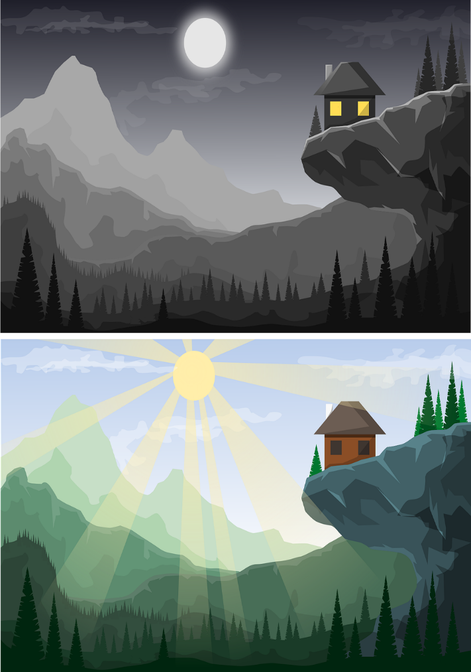**Item collection and use:** Collect various tools which will give you special abilities to traverse the map or an edge in darkness. Documents can also be collected to help explore the world, like maps, instructions and notes on potential shortcuts.
* **Exploration:** The world will make use of Spatial Awareness, locked doors, traps, and mazes to create challenges for the player. The player must collect tools and learn the map to escape the Stranger, hide, find documents and hidden items, and progress.
* **Stealth & Run:** The Stranger is unbeatable and constant. It is best to avoid with making minimal noise and light, but in the event the Stranger finds you, you can still use your Spatial Awareness and tools to ward it off and hide again in hide spaces, losing it in labyrinths or getting to safe areas that are still lit.
* **Puzzles:** These mechanics will range wildly, especially with new gimmicks provided in different areas. Find keys for locked doors, finish combination locks, repair generators by collecting supplies and using someone who can fix it and item collection and complete keycodes. Some puzzles can also only be completed in the day or night using solar cells, or with the right person.
* **Day and Night:** The world is in a constant cycle of day and night. The day provides exploration and puzzle challenges, while the night provides survival and horror challenges. The day and night are constant, but never equal as days can be longer and shorter randomly, and some areas are better accessed by day, while others by night.
* **Use the Light:** The Stranger is very sensitive to light, being driven away by the day, at least mostely. Use your trusty torch and drive it away by upping the light level, but be warned, this drains the battery quickly. Using the torch can also draw it to you. Generators and Solar Cells can also activate light to drive away the Stranger, but are prone to breaking down or losing light. Be vigilant and use the light.
* **Sleep as a Resource:** The Characters are affected by their sleep. As time goes by, their vision blurs, they move slower and can even be prone to falling asleep anywhere, a sure death sentence at night. Know the signs of exhaustion and be sure to get sleep before this happens. This will get you to decide: Explore and complete puzzles in the safety of the day, or risk sleeping at night, from which you may not wake. Better than not sleeping at all.

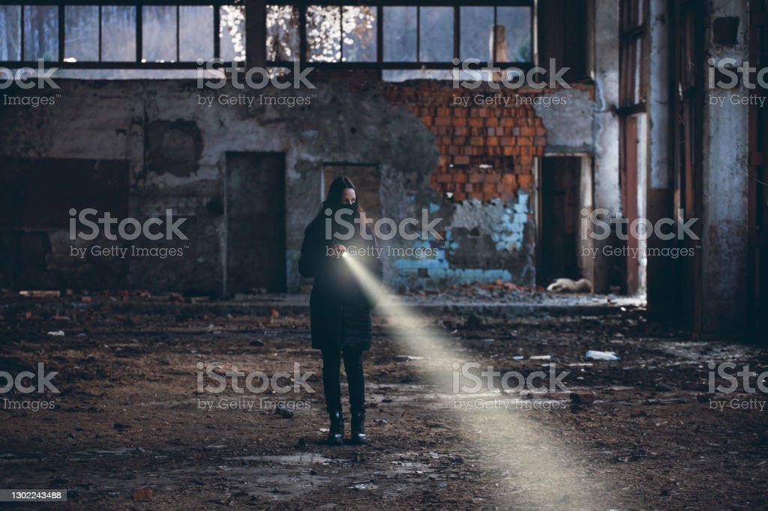

## Rules

* There are no Hit Points. If the Stranger reaches you in attack mode, it will trigger a death scene.
* The longer the player goes without sleeping, the more impaired vision (using grain, vignettes and lens at greater points) and movement (1 to 0.1) the character will have. At 0 sleep, they will be knocked out until they gain sleep.
* The player can eat supplies to regain some sleep, but this can only do so much. A superior version of supplies can also negate movement penalties.
* Fall damage, crush damage and electric damage can occur. Minor versions like falling down a hill, getting caught in a closing door or blowing a fuse will incur 10% sleep damage which can be repaired by eating or sleeping. Major damage will immediately knock out the character.
* Players can collect items to a maximum of 2 supplies, 2 batteries, and up to 3 variant items or tools.
* A player can use a flashlight to look at surroundings and scare off the Stranger by turning up the brightness. This can be upgraded.

## Controls

* WASD to move forward, backward, side to side.
* E key to pick up items and interact with objects.
* I key to use inventory
* Esc to open menu
* Scroll on mouse to change through tools and items, or use numbers 1,2,3,4,5,6,7,8,9.
* Press left mouse button to interact with the item with quick ability.
* Hold left mouse button to interact with the item slow ability.

## Interactive Elements

* Switches and buttons
* Doors
* Items and tools
* Locks
* Documents
* Inventory / Docs
* Generators
* Abseiling / Climbing points

## Physics

Physics will be slow and still, to create a dead sort of look to the world when the sun goes down. Gravity will be heavy and constant, restricting free climbing on some objects. Most objects won’t have physics in the game.

## Characters

**Nikki (Working Name): The Walker**

**Overview**: Nikki is a new Park Ranger for the area. After a traumatic run in with her stalker, the man was imprisoned and she went for a fresh start out in the middle of nowhere. Living out of her car, she dropped into the Forest for a breath of fresh air and to remember a time where she was free. But she found she couldn’t leave…

**Description**: Olive skin, deep red shirt (only see sleeves). No voice and simple character model as the game is entirely first person, with arms to signal some information and stats.

**Controls**: Walk, run, jump, interact, use tools.

**Abilities:** Stamina drains 25% slower than normal. She is also 20% harder to see by the Stranger, but she doesn’t have special skills. Basic repair (fuse replacement)

**Enemy:** Stranger (Stalker mode)

**Objective:** Beat the Stranger. Unlike the others, she’s motivated in proving that she’s bigger than her demons.

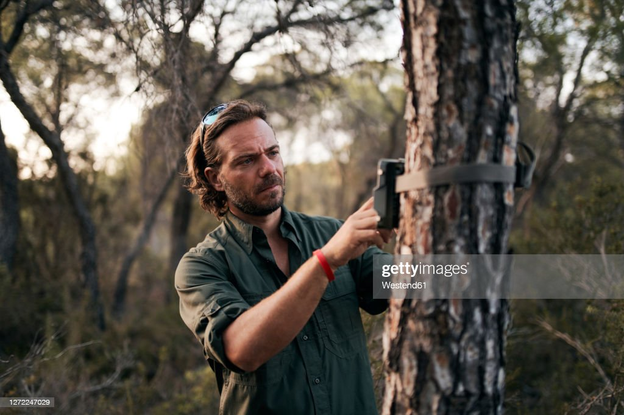**Noah Takken (Working Name): The Ranger**

**Overview:** Noah is the Park Ranger that runs the local Ranger home. After leaving his home when his girlfriend got pregnant and aborted, he disappeared into his new work. The guilt holds him down in nightmares and he cannot escape it. Slowly, it became clear there was other things he couldn’t escape.

**Description:** Short beard, blond, blue eyes, a light green uniform for the local Park Rangers. Short sleaves with a watch.

**Controls:** Walk, run, jump, interact, use tools, use ranger tool (Wrench)

**Abilities:** He suffers from lack of sleep, making him drain 10% faster in stamina. Basic repair (fuse replacement)

**Enemy:** Shame (Ambush mode / daytime attack mode)

**Objective:** Run away. No extra objective here. This will even include leaving people behind.

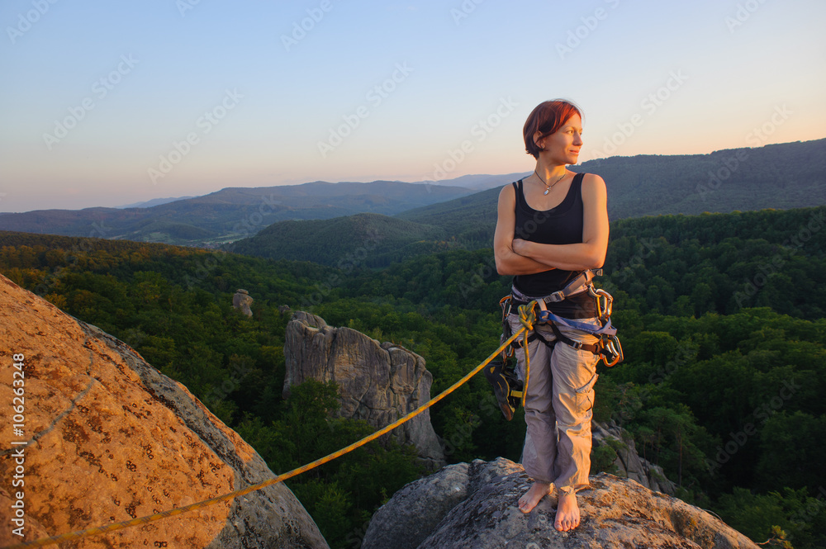

**Anna Winton (Working Name): The Abseiler**

Anna is a long time rock climber with a dark past. She used to rock climb with her best friend, but after a faulty rope, they both fell far below. She broke her leg, but her friend lost her life. After waiting for rescue for days, she had no choice but to eat her friend to survive.

Years later, she has healed but never rocked climbed again. However, she decided to go one last time to honour her friend’s memory the anniversary of her death. She picked a small area with little casualty rates and set off, only to find something more dangerous than a broken rope. Perhaps it was retribution.

**Description:** Black hair, native American, purple singlet and harness.

**Controls:** Walk, run, jump, interact, use tools, use climbing tool (rope), rope repair (fix knots), basic repair (fuse replacement)

**Abilities:** Default Stamina, default stealth, able to climb when no rope is present and leave a rope behind.

**Enemy:** Wendigo (Hunger mode)

**Objective:** Bury her friend’s remaining ashes. This will be done in altar areas.

**Brandon Etcher (Working Name): The Security Guard**

Brandon works as a guard for the Scientists who investigated the Nightmare phenomena. He was there when the facility fell, and was unable to do anything when the scientists killed each other in blind panic and illusions created by the Stranger.

Now he’s left alone, but somehow, he’s starting to feel that isn’t the case.

**Description:** Larger model, blue security uniform.

**Controls:** Walk, run, jump, interact, use tools, use security tool (taser)

**Abilities:** Though stealth is 50% less affective, he can survive 3 attacks by the stranger. Stamina is 25% less affective. Basic repair (fuse replacement), security repair (security bypass switch), Security scan

**Enemy:** Illusion (all mode)

**Objective:** Save as many as he can.

**Sharon Bjorn (Working Name): The Scientist**

Sharon is one of the last survivors in the facility, escaped only by being outside on a mission. She believed the research in Psychology of humans was invaluable, but didn’t realise just how dangerous the phenomenon was.

**Description:** White Lab coat.

**Controls:** Walk, run, jump, interact, use tools, use science tool (scanner)

**Abilities:** Stamina is 25% less but stealth is 50% more. Use science objects (test tube lab, ground scanner, radiation reader), basic repair (fuse replacement)

**Enemy:** Survivor’s Guilt (Horde mode)

**Objective:** Lock the creature away and escape with all the notes.

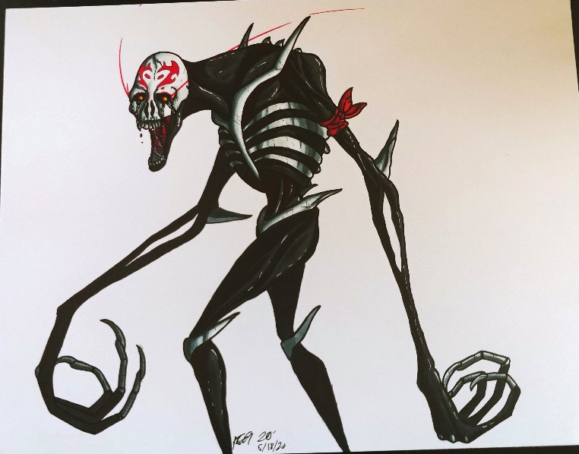

**The Stranger:**

**Overview**: An Otherworldly creature that haunts the area. Not much is known about it, except it is unbelievably old and affects the mind. It started with nightmares, hallucinations in campers and miners to the point where they left. It became an urban legend, a ghost story told by those who stay in the park for more than a week.

After scientists came to study the effect it has, it was able to feed on a lot of minds to the point that it was able to take a more physical form.

That is, until the scientists killed themselves to contain it and now it is desperate for more thoughts. Luckily, it appeared it still had some lost souls to feed on.

|  |  |  |
| --- | --- | --- |
| *Name* | *Description* | *Behaviour* |
| Stranger | Black and inky skin, thin and tall with red eyes. | Wanders randomly near the player at night. Attracted to light and attacks player when it spots them for a certain amount of time. |
| Shame | Pure white, red eyes, smaller and makes baby crying sounds. | Wanders randomly near player in the day. If player spots it, it will stand still. If watched for 1 – 5 seconds, it attacks. This number aggregates if looked away from, but not after despawning in player moves all the way away. |
| Wendigo | Similar to Stranger, but as pieces of flesh missing and no lips. | Wanders randomly near player at night. Spawns when player is below 50% in stamina and moves towards them. Will attack when player is 10% stamina. If faces them, it moves away. If creature reaches them it attacks. |
| Survivor’s Guilt | The creature will take a human form, slightly ethereal in science, security and park ranger form. | Up to 10 entities will spawn around the player at night and day. Only attacks at night. They do not move when player spots them. When player doesn’t face them, they move closer. If more than 2 reach the player, it reaches attack mode. |
| Illusion | The Stranger takes on any of the forms. | Behaviour is randomised from the behaviour above. This will correlate with how it looks. If stunned, it switches between forms before disappearing. |

## Tools

As you progress, you will collect tools to help you survive and traverse the world. You can only wield one tool at a time, but can carry up to 3. However, there are tools only some of the characters can wield.

|  |  |  |
| --- | --- | --- |
| *Name* | Behaviour | Usage |
| Wrench | Use on mechanical items to fix them if broken. (generator, grid, solar cells, science equipment, electronic doors) | Ranger |
| Rope | At rock climbing sections, set up a rope to climb up and down. | Climber |
| Taser | Point and click to send a shock to creatures. This will stun them for a short while. | Security, uses battery |
| Scanner | A radar system that will tell when the creature is coming to you or show points of interest. | Science, uses battery |
| Torch | Shine light in darkness. Switch to high beams for a brighter light. | Ranger, Walker, Climber, Security and Science, uses battery |
| Power Torch | Shine light in darkness. Switch to high beams for a brighter light. Lasts longer. | Ranger, Walker, Climber, Security and Science, uses battery |
| Compass | Navigate by knowing which direction North is. | Ranger, Walker, Climber |

## Items

One off items and consumables can be found in the world. Some can stack in the inventory, and the little difference between item and tools is items cannot be equipped, just used when interacting.

**Supply bag (Supply chest):** A consumable bag of food and nutrients which can ward off sleep for a time and provide special additions.

* **Blue Stripe:** Standard, heals some sleep damage.
* **Red Stripe:** Caffeine, heals some sleep damage but stops sleep damage for a short time.
* **Green Stripe:** Pain medicine, causes sleep damage but lets you move a little faster for a short time.

**Batteries (Supply Chest)**: This item is a consumable item to power electronic tools. Equip a tool, then consume in inventory to put more power into that tool.

**Fuses (Random areas):** This item is constant, with only a few in the world. Consume them by interacting with a fuse box or generator (only a set amount in the world) to repair the item.

**Fuel Tank (Random areas):** There is only a set amount of fuel containers in the world. Use them by interacting with a generator to fill the generator with fuel. A fuel tank can fill two generators.

### Access Items

These are non-consumable items which are used to do various things, specifically to open doors or new areas. Upon death, this is randomly placed throughout the world the same as other items.

**Keys (Random Areas):** A key can open padlocks and doors in the world of a corresponding colour.

* **Blue Key:** A key that opens the Ranger’s Complex resource room and a cabin in the campsite area.
* **Green Key:** A key that opens cabins in forest, watchtower in campsite and altar room in laboratory.
* **Red Key:** A key that opens 1 building in Industrial and 1 science room in lab.
* **ID level 1 card (Forest):** Opens an id reader to get into a small area in the forest and some rooms in the laboratory.
* **ID level 2 card (Industrial):** Opens id readers that lead to the laboratory and some areas in industrial zone, as well as some rooms in the laboratory.
* **ID level 3 card (Laboratory):** Opens the final area in the laboratory and with using all 3 cards, locks a major room. The end game is locking the Stranger into that room.

**Chest Piece (Set areas):** Scattered around the world are chest game pieces. Find all the white pieces (main game) to get the special reward, the sleeping bag, which would allow you to sleep safely at night. This would be helpful during the Nightmare game mode, in searching more documents, tools and the black chest pieces. (Black chest pieces only give you insight into Nikki’s thoughts and story in a darker tone, no physical game reward).

## Documents

**Diary Pages:** Throughout the world, Nikki can find pages from a diary, owned by Noah. This will detail his job, why he came out there, and the nightmares he’d been having. Eventually, you’ll come across a page that has him talk about going to the lab in the mountains, but you won’t find him there or anywhere.

**Reports and Documentation:** These are reports written by people in the lab or miners, as well as documentation and instructions to find out how to open or repair things, as well as flavour reports on the Stranger, it’s nature and how it affected people.

**Nikki’s Thought Diary:** This is documentation that is constantly in your possession. A diary that can be reached in your inventory. Every time you come to a new area, or discover a special item (a tool or a chest game piece), you can look at your own diary to see some insight to Nikki’s story and why she came here, as well as pictures she’s taken.

## AI and Behaviour

There AI of the Stranger is split between 6 core states, a variety active depending on what enemy you meet:

* **Attack:** Move to player and attack.
* **Run:** Move away from player to a safe distance, before beginning despawn.
* **Patrol:** Move along a random path, until they see the player. This path is randomly placed, calculated to either move randomly or slightly toward the player. When a player makes a sound or shines too much light, it will enter investigate state.
* **Despawn:** Disappear into the ground or air with no trace. This uses a black smoke to do this.
* **Investigate:** When it hears the player (player running or using object) or sees a light, it will move towards the sound / light. After going there, it would randomly check the area and look around objects until it either finds the player or moves on. The Stranger losing sight of the player during attack mode can also enter this state for the last known position of the player.
* **Idle:** A default state for the creature. They stand still and look around, moving in and out of this state as it changes other states.

The Stranger simulates a desperate creature, not too smart but running on their own fight and flight. They’re in search of the Nikki to terrorise her, keep her there with it, and stalk her.

## Balance

While the core game mechanics are designed to be difficult, balance is created through the day and night cycles. The day is safe, giving the player breathing room to plan, collect items, and read documents. The night is designed to be all out, all the time. The Stranger is relentless and unpredictable. To being with, you may get more day than night, around 6 minutes for the day and 4 for the night. This, however, which change every day, with one more minute added to the night until there is only 2 minutes of day to 8 of night. The difficulty will force the player to get things done quickly, until their eventual demise.

## Tutorial

The tutorial will be worked into the first act of the story. It would start with a breakdown of Nikki’s vehicle just outside the Forest level in the afternoon. This will walk through player controls of moving, interacting, and picking up items / tools (the first of which is a key for a gate and the torch.

Follow the road to a small cabin and a locked gate. You’ll pick up the torch to explore the cabin, get a key, and open the gate, leading to the forest. From there, you’ll find a larger complex of many cabins for the Rangers, but no one is there.

In this complex, once again locked from the forest. Here, the player will learn the repairing and sleeping mechanics as they fix a generator with a fuse and fuel, then sleep. This first sleep will wake Nikki up in the middle of the night, with the generator turned off.

The creature will come and you have to run and hide in the complex, trying to get back to your car. Once you reach the now closed gate, the player is forced into getting captured. They will wake up in the forest and the main game begins.

Tools and other items are learned intuitively or with instructions later.

# **Narrative**

## Style and Structure

The story based around horror, specifically the idea of stalkers and threats from stalkers, as described in Nikki’s background as well as the over arcing story. The structure will be linear, as progression would unlock more story points, but the narrative will play out in iterative days with living, dying and repeats. Most of it will be told through documents and found items.

## Background Story

The story takes place in a Wildlife preserve, which encompasses an old camp and mining facility. The camp went out of business years ago, before the mining facility, but after a few years of mining, the workers began to complain about nightmares and lack of sleep. When an accident happened, the facility was shut down.

A number of years later, a team of scientists came to research the phenomena of the nightmares, as they were constant and consistent over everyone. They built a lab within a mountain and kept volunteers to see what happens. The nightmares returned, and participants started seeing hallucinations.

Around this time, Noah was enlisted to keep watch of the preserve, now owned by the Government. He started seeing nightmares and hallucinations as well, of a crying child. He set out to look for this child, but because of this reaction, and Noah’s guilt of his aborted child, the Stranger was born into its new, physical, form. It wreaked havoc in the lab, and they evacuated, with Noah missing.

Nikki, running from an abusive boyfriend-turned-stalker, takes Noah’s job in the middle of no where to hide. When she approaches, the Nightmare monster, starved, takes it’s new form and stalks Nikki. Her greatest fear incarnate.

## Storyline

Nikki comes to the Nature Preserve and starts working her job, surprised that there is no one to greet her at all and her car is broken down. After meeting the Stranger, she now has to find a way to escape her loop of death, fear, and the menacing presence she knew all too well.

# **Visuals**

## Style

Due to graphic constraints, the style will remain simplistic with mostly solid colours. The colour saturation will change from day and night, being colourful and calm in the day, and dark and foreboding at night.

## World

Each area comes with their own mechanics and styles. The area designs will have the same simplistic look and feel, but will coming with their own designs and colours. Look at (Appendix 2.1, 2.2) for descriptions and maps.

* **Tutorial:** This would be the least overgrown of the areas, save the lab. The world is open, except for this linear exception for learn how to do things in the world. Log cabins and dirt roads will be the focus of this level, similar to camp.
* **Forest:** The Forest is the most natural aspect, using dirt tracks and trees everywhere with only a few buildings, watchtowers and tents scattered around the area. Greenery, grass and trees will comprise most of the level, open and easy. It also serves as a hub for the world.
* **Campsite:** In a semi-fenced off area, there is a cluster of overgrown cabins around a lake. These will be log cabins, a dock, and several camp ground areas / barracks. This will focus more on locked doors, finding keys and hiding in rooms, and configuring the generator in the area.
* **Mining Facility:** This will be an abandoned urban town, a single cluster of buildings in the shadow of the mountain, Most of the area is burnt forests and mining equipment, but urban compared to the rest of the game. Many areas are locked off my mechanical equipment you need to fix and power to move to create bridges and remove obstacles.
* **Laboratory:** This is an inside level, burrowed into the mountain itself. This has the least life, with dark white corridors that you need to power with generators, careful to conserve power and not trip the system.

# **Music and Sounds**

## Style

To match the horror style, the music will be simple and unnerving, focusing on single dissonant cords, cord progression and performing media. The day will be calmy, peaceful and use acoustic instruments for a more laidback and country feel.

* **All (Night):** Unnerving cords, large silences, focus on ambient sounds.
* **Ranger’s HUB (Day):** Nikki’s theme, an acoustic improve that is likely she played herself on guitar.
* **Forest (Day):** Use of flute with acoustic guitar, large silences for focus ambience.
* **Camp (Day):** Banjo replaces the guitar as the main instrument, but uses the same cord progression and song as Forest.
* **Mining Facility (Day):** This will go back to acoustic guitar and playing Nikki’s theme, with some percussion instruments behind it. This is the main progression for Nikki, so it would sound like it.
* **Laboratory (Day):** There will be full deviation from the acoustic sound, going into more eerie and synth / string sounds. Because it’s always night in this level, this will take over the night sound, but play with the same cord progression and soundscape.

## Ambience

Each area will have different sounds:

* **All (Night):** Sound of wind and clicking.
* **Ranger’s HUB:** Creaking wood, bird sounds, wind (whistle) sounds.
* **Forest:** Bird sounds, wind (no whistle) sounds, snapping branches.
* **Camp:** Creaking wood, bird sounds, wind (whistle) sounds.
* **Mining Facility:** Groaning metal, falling rocks, wind (whistle) sounds.
* **Laboratory:** clicking metal, groaning metal.

# **Technical Aspects**

## Technologies

**Unity:** Low processing, easy to use Object-oriented design, with quick and easy use of audio, visual and mechanical components.

## Tools

**Blender**: Model, animation and texture design and implementation into models used by Unity.

**Garage Band:** Audio and music design, good for use in simple and acoustic scores.

# **Appendix**

* 1. ***Tools:***

|  |  |  |  |  |
| --- | --- | --- | --- | --- |
| Name | Description | Quick Ability | Slow Ability | Image |
| Torch | **A large cylindrical torch that shines light.**  **A larger torch can be found in the camp to use the second ability.**  **Location: Forest**  **Laboratory** | **Switch light on and off to see in the dark.** | **Enhance brightness to scare off the Stranger.** |  |
| Crowbar | **A blue painted crowbar that can unlock rusted locks.**  **A newer version can be found in the Laboratory to open metal doors.**  **Location:**  **Forest**  **Industrial** | **Use a quick strike to destroy rusted locks and small wooden things like chest locks and small locks.** | **Hold for a longer strike to break metal handles on metal doors, and wooden barriers.** |  |
| Repair Kit | **A kit to allow you to repair electronic things. Better versions can be found for more intricate stuff and minigames**  **Location: Camp**  **Industrial** | **A quick patch to stop sparking or making sound. Can be used on most electronic things.** | **Start a minigame to fix things like generators, fuse boxes and key pads.** |  |
| Snare Trap / Bear Trap | **A small snare trap that can be used to slow the Stranger.**  **A bear trap can be found to stop the Stranger entirely for a while.**  **Location:**  **Camp**  **Industrial** | **Put a snare trap (up to 3) on the ground. If triggered by the Stranger, it will slow the creature for a few seconds, but it can also slow you if you step in it.** | **Put down a bear trap instead of a snare to stop the Stranger entirely for a few seconds, which can work on you and cause 25 sleep damage.** |  |
| Trip Wire / Motion Trip | **A trip wire that can be placed on the ground which will make a sound if the Stranger steps on it. The motion tracker can be placed on walls and objects and if something walks passed it, it will make a sound and flash a light.**  **Location: Industrial**  **Laboratory** | **Place the trip wire (up to 3) on the ground. If the Stranger passes over it, it will release a one off sound and breaks.** | **Place a larger motion tracker on the wall. If the Stranger passes over it, it will release a bright light and a large sound, which will scare off the Stranger. The light is a one-off use.** |  |
| Absailing Gear / Climbing Gear | **Climbing picks and rope. The rope can be placed at absailing points to climb down dangerous cliffs. The climbing gear allows you to climb up abseiling points.**  **Location:**  **Industrial**  **Forest** | **Use a quick action to place a rope at an abseiling point. The upgraded gear can get you to place it at the bottom of the cliff, too.** | **Use a slow action to begin climbing.** |  |
| Motion Sensor | **A handheld sonar which will tell you the direction and distance of a creature. This uses batteries.**  **Location:**  **Laboratory** | **Switch on and off. The sound can attract.** | **Make the distance greater to see further for a small amount of time.** |  |

* 1. ***Level Descriptions and Colour Schemes:***

|  |  |  |
| --- | --- | --- |
| Level | Description | Image |
| Ranger’s HUB | **Grey, black, blue/green light**  **Dead trees, abandoned buildings, ashen ground.** |  |
| Forest | **Brown, yellow, white light**  **Mechanical objects, rust, robotics, conveyor belts, pipes.** |  |
| CAMP | **Gold, Bronze, White, yellow light**  **Cogs, clocks, stairs and platforms, elevators.** |  |
| Mining Facility | **Green, Red, Blue, Green light**  **Trees, plants, vines, water, bridges, floating particles.** |  |
| Laboratory | **Brown, Beige, Red light**  **Books, workbenches, jars, glowing capsules, mechanical equipment.** |  |

# **References**

Tyrell, N (nd) *A rendering of "Slender Man" by artist Nick Tyrell* [image]*.* (nd), <https://www.nbcnews.com/storyline/slender-man-stabbing/slender-man-s-seductive-power-kids-it-s-brain-n124401>

Newlyn L (2018) *The Torchman* [image]. (nd), <https://lucynewlyn.com/the-torch-man/>

*Factory ruins in a wooded area. Abandoned building and forest road* [image]. (nd). <https://www.dreamstime.com/factory-ruins-wooded-area-abandoned-building-forest-ro-road-season-autumn-image133617682>

*The Horned Shadow about to take another victim.* [image]. (nd), <https://cutlerverse.fandom.com/wiki/Wendigo>

TJFREE (2020) *[No Name]* [image]. (nd). <https://pixabay.com/vectors/landscape-mountain-moon-sun-night-5201075/>

Hawk_Style (2021) *Lonely Girl with a Flashlight Walks in an Abandoned Room stock photo* [image]. (nd). <https://www.istockphoto.com/photo/lonely-girl-with-a-flashlight-walks-in-an-abandoned-room-gm1302243488-394041310>

Boris Edelmann/Shutterstock(nd) *Bodie Ghost Town, California* [image]. (nd). <https://www.roughguides.com/gallery/abandoned-places/>

Cavan Images (nd) *Woman explorer and geographer analyzes the environment - stock photo* [image]. (nd). <https://www.gettyimages.com.au/detail/photo/woman-explorer-and-geographer-analyzes-the-royalty-free-image/1316450894?adppopup=true>

Cavan Images (nd) *Woman explorer and geographer analyzes the environment with a compass - stock photo* [image]. (nd). <https://www.gettyimages.com.au/detail/photo/woman-explorer-and-geographer-analyzes-the-royalty-free-image/1316450982?adppopup=true>

Cavan Images (nd) *A woman explorer walks along a dirt road observing nature - stock photo* [image]. (nd). <https://www.gettyimages.com.au/detail/photo/woman-explorer-walks-along-a-dirt-road-observing-royalty-free-image/1316451017?adppopup=true>

PantherCaboose (2020) *RWBY: Vale Apathy* [image]. (nd). <https://www.deviantart.com/panthercaboose/art/RWBY-Vale-Apathy-852437877>

Westen61 (nd) *Man adjusting the settings in trail camera mounting on tree trunk in forest - stock photo* [image]. (nd). <https://www.gettyimages.com.au/detail/photo/man-adjusting-the-settings-in-trail-camera-mounting-royalty-free-image/1272247029?adppopup=true>

anatoliy_gleb (nd) *Young woman climber standing secured with rope on big rock at mountain peak with bare foot enjoying the beautiful sunset view. Warm sunny evening in the mountains. Climbing equipment.* [image]. (nd). <https://stock.adobe.com/au/images/young-woman-climber-standing-secured-with-rope-on-big-rock-at-mountain-peak-with-bare-foot-enjoying-the-beautiful-sunset-view-warm-sunny-evening-in-the-mountains-climbing-equipment/106263248>

security one 2 one (nd) *What Security Guards Can Do For You* [image]. (nd). <https://securityone2one.com.au/what-security-guards-can-do-for-you/>

SIGRID GOMBERT / CULTURA / SCIENCE PHOTO LIBRARY (nd) *Portrait of young female scientist in lab* [image]. (nd). <https://www.sciencephoto.com/media/674741/view/portrait-of-young-female-scientist-in-lab>